Dis-AM,C-Costa Rica-Guanacaste, Nicoya-Female Effigy- ca. 200 BCE - 200 CE.

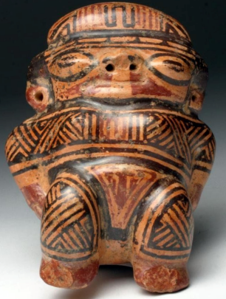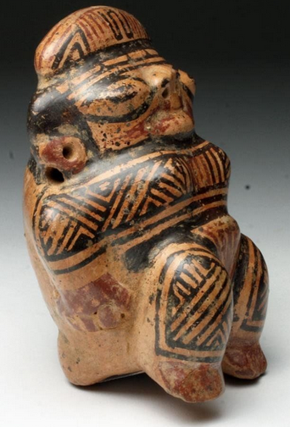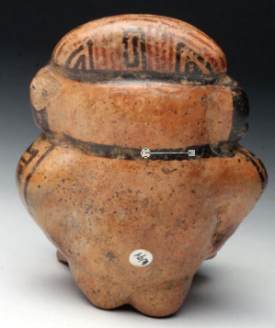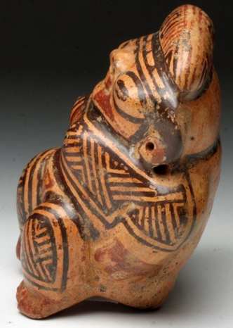

Guanacaste-Nicoya Female Effigy from Costa Rica, ca. 200 BCE - 200 CE

Case No. 14

**Formal Label:** Guanacaste-Nicoya Female Effigy from Costa Rica, ca. 200 BCE - 200 CE

**Accession Number:**  F1545.3.P6

**Date or Time Horizon:** 500 to 1000 AD/CE AD

**Geographical Area:** Guanacaste-Nicoya Area, Costa Rica

**Cultural Affiliation:** Nicoya

**Medium:** Ceramic

**Dimensions:** H 4 1/3 in, W 3 ½ in, D 2 ½ in

**Weight:** 10.2 oz

**Provenance:** Ex-Gilbert Martin Collection, Georgia, USA; Ex-Artemis Gallery

**Condition:** Excellent condition.  Has one chip on back of left ear and does not affect visual appearance.  See picture.

**Discussion:** This female effigy figurine possesses the elegant styling of the Guanacaste-Nicoya Galo polychrome style. Its mirror-bright burnished surfaces with a vivid trichromatic style in red and black on cream ground and an ornately decorated surface with interlocking geometric patterns adorn this figurine’s headdress, costume, and tattoos. This polychrome tradition represents an important form of socio-economic expression that was designed to articulate the involvement of the Nicoyans in a northern trade network that brought jade, slate-backed pyrite mirrors, foreign ceramics, and other luxury goods to the Nicoyans. In turn, they responded by producing their own special ceramics, partly inspired by northern models, but integrating northern and southern elements, forming a unique hybrid style that was traded throughout Central America and southern Meso-America (Abel-Vidor 1981).

Not only is this figure elaborately painted but it also shows additional forms of bodily ornamentation such as the knotted headband and large earspools. The attention to these bodily details suggests that the figure is a female representative of the economic élite. The black spotting particularly visible on backside represents manganese oxide deposits that develop with prolonged burial. This female effigy was most likely placed in a grave to grant the deceased rebirth in the afterlife (Hardy 1992).

**References:**

Abel-Vidor, Suzanne. 1981. Ethno-historical approaches to the archaeology of Greater Nicoya. In Suzanne Abel-Vidor,*Between continents/between seas: Pre-Columbian art of Costa Rica*. New York: Abrams.

Hardy, E.T., 1992. *The mortuary behavior of Guanacaste/Nicoya: an analysis of precolumbian social structure* (Doctoral dissertation, UCLA).

Healy, Paul F. 1980. *Archaeology of the Rivas Region, Nicaragua*. Waterloo, Ontario: Wilfrid Laurier University Press.

Healy, Paul F. 1988. Greater Nicoya and Mesoamerica: Analysis of Selected Ceramics. Chapter 13. In Frederick W. Lange, ed., *Costa Rican Art and Archaeology: Essays in Honor of Frederick R. Mayer*. Pp. 293-301. Boulder: Regents of the University of Colorado.